NEST360 Data Manager Position – Stage 1 Assessment March 2026 ANALYSIS REPORT
NEONTANAL DATASET ASSESSMENT: DATA QUALITY, DESCRIPTIVE ANALYSIS AND HOSPITAL-LEVEL TARGET SETTING (2025-2028)
Programme: Newborn Essesntial Solutions and Technologies (NEST350)
Dataset Analyzed: NID.xlsx | Reference period: 2025
Prepared by: Charles Daniel Apollo Doka
Date: 12 March 2026

Content
No. | SECTION
A | Data Quality Assessment (DQA)
B | Derived Variables for Analysis
C | CPAP Coverage Analysis & Hospital Variation
D | Target for 2028
 | Conclusion and Programme Implications

Introduction:
This report presents findings from a structured analysis of neonatal admissions data collect across hospitals participating in the NEST360 program. The primary objective is to assess Continuous Positive Pressure (CPAP) coverage among neonates weighing 1,000-1499 grams_ and high-risk group of very birthweight (VLBW) infants who frequently require respirator support.
The analysis was conducted in R (libraries used : dplyr, tidyr, lubridate, ggplot2, readxl writexl) using a fully reproducible workflow, encompassed data quality checks, derivation of clinical indicators, descriptive statistics, and hospital-level benchmarking to establish realistic improvement target for 2028.
The assessment report covers 4 interconnected areas: data quality assessment (A), derivation of analytical variables (B), CPAP coverage analysis and hospital variation (C), and target setting through to Dec 2028 (D).Three visualizations are embedded to support interpretation.
The three visualizations support interpretation of the findings:
- 2025 Baseline vs December 2028 CPAP Coverage targets- Main visual for this assessment
- Distribution of CPAP coverage across hospitals –Additional insight
- Hospital ranking by CPAP coverage- Additional insight

SECTION A: Data Quality Assessment
A1-Completeness of Key Variables
The dataset was first assessed for missing values across all variables. The table below list the six analytical critical fields. Missingness in these variables directly affects the reliability of coverage estimates and the validity of derived indicators.
Variables | Analytical Role
in_bwt (birthweight) | Primary weight variable, used as fallback when admission weight is absent
in_admwt (admission weight) | Preferred weight for CPAP eligibility classification
in_cp_admin (CPAP status) | Numerator and denominator of coverage calculation
in_doa (date of admission) | Required for age at-admission and years stratifications
in_doa (date of birth) | Required for age at admission derivation
in_dis_dod (discharge/death date) | Required for length of stay calculation

Missing CPAP administration records are the most consequential gap. Records with missing CPA status are excluded from coverage denominators, rather than imputed, to avoid introducing spurious precision into coverage estimates. If missingness is non-random (e.g, concentrated in high alertness or poorly resourced facilities), this exclusion may systematically bias coverage upward or downward. Where admission weight was absent, birthweight was substituted using a tracked variable (weight-sources) to preserve eligible records while enabling sensitivity analyses.
A2-Qulity Flags: Implausible and Inconsistent Values
Six logical flags were applied to identify potential data entry errors or recording inconsistencies. These flags do not automatically exclude records; they tag observation for review and inform how derived variables are calculated.
Flag | Condition Detected | Analytical Treatment
Birthweight outside 100-6000 g | Implausible neonatal weight | Excluded from weight-ban classification
Admission weight outside 100-6000 g | Potential recording error | Excluded from weight-band classification
Admission weight> birthweight | Impossible physiological sequence | Flagged, record retained, weight checked
Discharge before admission date | Impossible clinical timeline | LOS set to NA
Admission before date of birth | Data entry error | Age at admission set to NA
Discharge before date of birth | Impossible temporal sequence | Both LOS and age set to NA

A3-Impact of Data Quality Issues on Analysis
Three categories of quality problem carry the greatest analytical risk:
Missing CPA Status: Exclusion from the denominator is statistically sound but reduces sample size and may skew coverage estimates if facilities with more missing records have systematically different CPAP practices. The magnitude of potential bias should be explored by comparing the proportion missing across facility performance tiers.
Incorrect weights: Misclassified weight values outside 100-6000 g are excluded; borderline implausible values (e.g, 700 g recorded as 7,000 g) may pass range checks but remain incorrect.
Date inconsistencies: Negative or zero length of stay and impossible age-at-admission values are set to NA and excluded from summary statistics. This is the conservative and correct approach; however, the proportion of records affected should be reported transparently as limitation.
A4-Recommendationss to Improve Data Quality
- In the electronic or paper data capture tool, prevent impossible date sequesqueces (discharge≥ admission≥ birth) out of range weight values, and negative durations. Introduce point of entry validation rules.
- Clearly distinguish birthweight from admission weight in training materials and data entry forms particularly for transferred neonates. Standardize weight measurement protocol.
- The system should not allow a record to be saved without a CPAP administration value, or should require an explicit “not applicable/contraindicated’ response .Make CPAP status a mandatory field.
- Automate flag reports shared with facility data clerks and supervisors crate peer accountability and enable early correction of system errors.Condcut monthly facility-level data quality assessment reviews periodically.
SECTION B: Derived Variables for Analysis
Eight variables were derived from the raw dataset to support the analysis. These variables would be retained in any exported final analytical dataset and are described below:
Variable | Type | Definition
age_at_adm | Numeric (days) | Admission date minus date of birth. Set to NA where admission precedes birth
los | Numeric (days) | Discharge/death date minus admission date. Set to NA where discharge precedes admission
bwt-cat | Ordered factor | Birthweight band:<1000 g|1000-1499 g|1599-1999 g|≥2000 g
admwt-cat | Ordered factor | Admission weight band using the same four categories
weght_for_cpap | Numeric (g) | Admission weight (preferred), birthweight substituted when admission weight is absent
weight_source | Character | ‘admission_weight’ or ‘birthweight_substituted-track which sources was used
wt_1000_1499 | Logical | TRUE when weight_for_cpap falls within 1,000-1499 g. Primary eligibility flag.
adm_year | Integer | Calendar year extracted from admission date using
Key Analytical Decisions
Weight category cut-points align with international recognized clinical threshold (VLBW <1,000 g; VLBW 1000-1499 g, LBW 1,500-1999 g, non-LBW ≥2000 g).Right-closed intervals lowest= TRUE ensure every non-missing weight is assigned a category.
Dual-source weight variable. Admission weight is the clinically preferable measure for post-delivery assessment where absent, birthweight is substituted. The weight source flag enables a planned sensitivity analysis-comparing coverage estimates using admission weight only versus the combined source, to quantity any bias introduced by substitution.
Date-derived variables. Setting impossible value to NA (rather than zero or negative) is the statistical conservative and correct approach. Analyst should always report the number of records excluded for each derived variable and assess whether exclusions are randomly distributed across facilities.

SECTION C: CPAP Coverage Analysis & Hospital Variation
C1-Coverage Defination
CPAP Coverage= (Neonates 1,000-1499 g receiving CPAP) / (Neonate 1000-1499 g with known CPAP status) x 100
This definition explicitly excludes records with missing CPAP status from both numerator and denominator, ensuring that missingness does not artificially inflate or deflate coverage estimates. Only neonates in the 1000-1499 g weight band are included, using weight_for_cpap as the eligibility criterion.
C2-Distribition of Coverage Across Hospitals
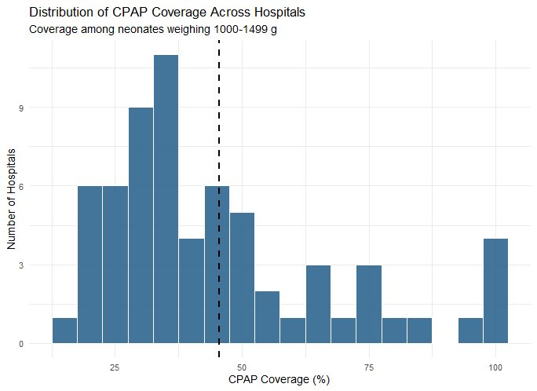

The histogram reveals a right-skewed, multi-modal distribution. The largest cluster of hospital falls in the 25-45% coverage range, a second smaller cluster in the 60-75% range, and a distinct high-performing group achieves coverage above 90%.This pattern is not consistent with a single homogenous population of facilities, it suggests the existence of atleast two or three distinct performance tiers within the network.
The multi-modal patter indicates that systemic factors, not random variation, drive the performance gap.Facilites achieve >90% coverage demonstrate that high CPAP coverage is clinically and operationally achievable in this programme context.
C3-Hospital Ranking and Magnitude of Variation

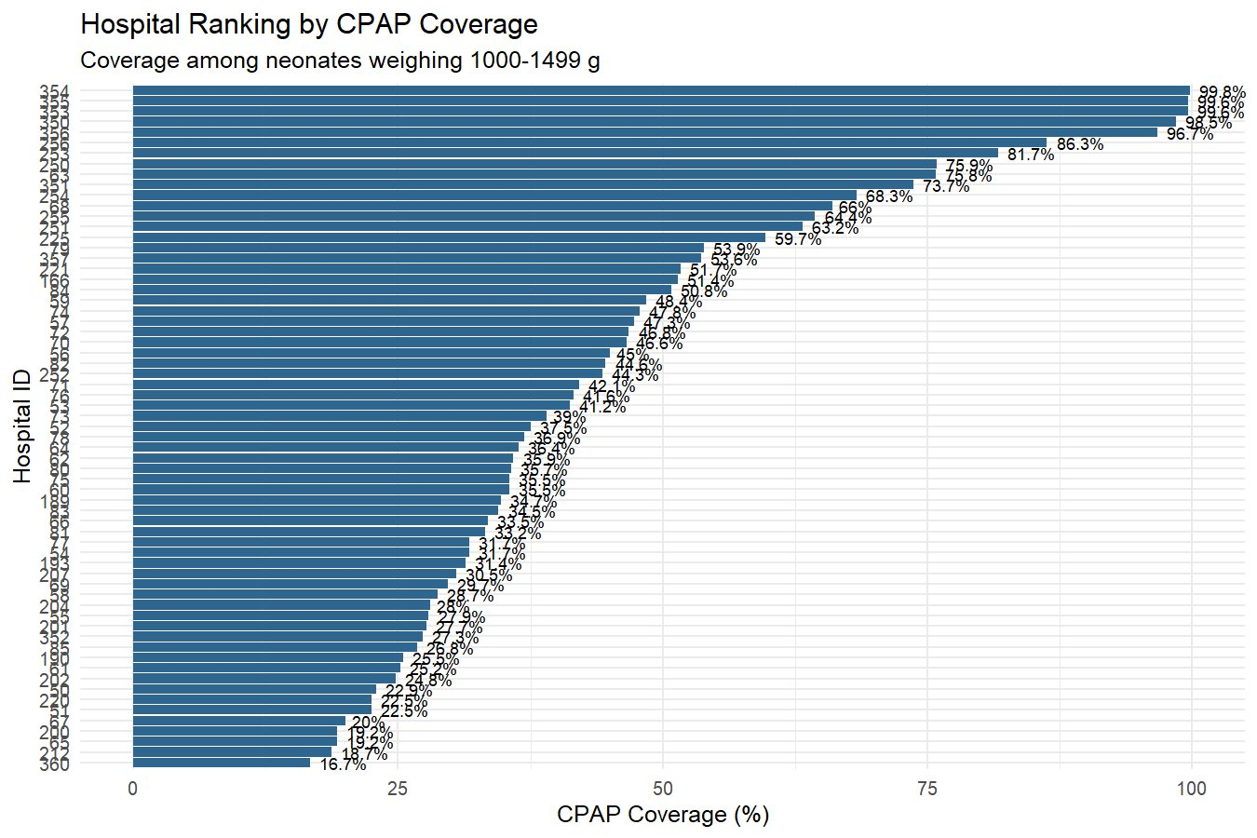
The ranking lot makes the scale of variation immediately visible.CPAP coverage ranges from 16.7% (hospital 260) to 99.8% (hospital 354), an 83 percentage point spread across facilities operating within the same programme. This magnitude of variation far exceeds what is explicable by difference in patient case mix alone.
Performance Tier | Coverage Range | Likely Contributing Factors
High performers | >75% coverage | Functional equipment, trained staff, embedded protocols
Mid-tier | 30-75% coverage | Partial capacity, systems barriers, training gaps
Low performers | <30% coverage | Equipment gaps, supply chain failures, minimal training
The bottom quartile, facilities below approximately 28% coverage, account for the greatest proportions of the quality improvement opportunity by volume. The mid –tier cluster (30-55%) represents the largest single group and is arguably the most tractable target for improvement, these facilities are already administering CPAP but at sub-optimal rates, suggesting addressable systems barriers rather than a complete absence of the intervention.
SECTION D Target Setting for December 2028
D1-Methodology: Benchmarking+ Equity Framework
Targets were set using a four-rule hierarchical framework that balances clinical ambition equity considerations and operational realism. The rules are applied in sequence.
No. | Rule | Value/Logic | Justification
1 | Peer benchmark | 75th percentile of 2025 hospital coverage | Anchor ambition in observed peer performance, what the quarter already archives, rather than an arbitrary external figure. Avoids setting unachievable targets in low resource contexts
2 | Equity boost | +30 pp for hospital below 30% | Accelerates catch-up for the most disadvantaged facilities .A fixed additive boost ensures an meaningful absolute gain regardless of starting point.
3 | Minimum floor | 60% for all hospitals | Reflects NEST360’s lower bound of clinically acceptable coverage prevents low performers from accepting a target that merely continues poor practice
4 | Maximum ceiling | 95% for all hospitals | Acknowledges that a subset of 1000-1499 g neonates have genuine contraindication to CPAP.  Prevents perverse incentives to administer CPAP inappropriately to reach 100%

D2-Target Computation
Baseline coverage was calculated separately per hospital using only 2025 records, filtered to the 1000-1499 g weight band with known CPAP status. The 75th percentile (p75) of the hospital-leveed 2025 coverages was computed as the benchmark value. The equity boost was applied to facilities below 30%, followed by application of the 60% floor and 95% ceiling
Two monitoring metrics were derived from the final targets and included in the output dataset
- Absolute improvement required = target 2028- baseline coverage
- Monthly improvement rate = absolute improvement /36 months
The monthly improvement rate translates each hospital’s target into a practical, scoreable monthly milestone. Enabling programme managers to identify facilities behind trajectory before the 2028 review deadline.
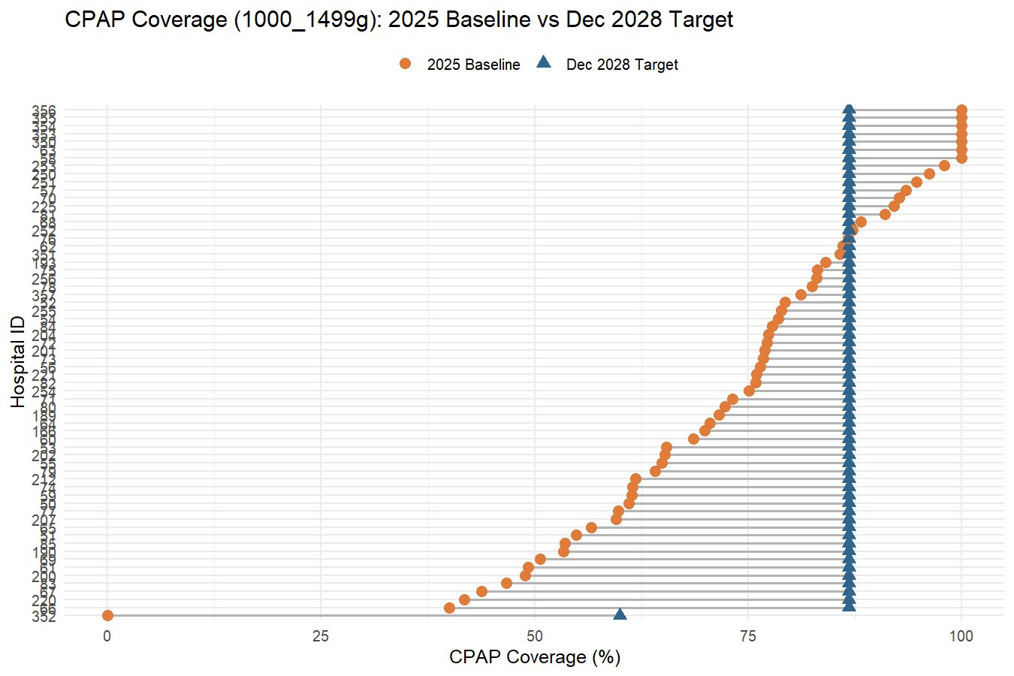
D3-Baseline vs 2028 Target: Visualization
The dumbbell plot above illustrates the scale and direction of the required improvement for each facility. Several key patterns visible:
- High performing hospitals already at or near 95% show minimal or zero required improvement, they are expected to maintain performance
- The majority of mid-tier hospitals show 15-30 percentage-point improvement required over 36 months translations to approximately 0.5-0.8 pp/month, ambitious but achievable with structured support.
- The single near-zero performer (Hospital 352) is assigned 60% floor as its 2028 target, representing a transformation change requiring intensive programme support
- The convergence of target triangles in the 85-95% range reflects the equity compression effect of the floor and ceiling, narrowing the gap between strongest and weakest facilities over time.
Conclusion and Programme Implications
This assessment analysis reveals a programme network in which the technical capacity to deliver high CPAP coverage clearly exits, served hospitals already achieve coverage above 90%, but where that capacity is very unevenly distributed. The 83perccentage point range between the best and worst performing facilities is the defining quality challenge for NEST360 programme through 2028.
The proposed target framework is deliberately structured to address this inequity .By anchoring ambition is observed peer performance (5th percentile benchmark) accelerating catch-up for the lowest performers (equity boost) protecting against inadequate targets (60% floor) and maintaining clinical realism (95% ceiling ) the framework creates a tiered improvement path that is both and demanding.
Priority Area | Recommended Action
Bottom-quartile | Conduct urgent diagnostic facility visits to assess equipment functionality, supply, chain and training needs. Assign programme mentors
Mid-tier hospitals | Engage in structured quality improvement collaborative with quarterly milestones. Share protocols from high performing peers
High performing hospitals | Leverage as peer mentors. Review and document their clinical protocol and training approaches for scale up across the network
Data quality | Implement point of entry validation, mandatory CPAP field and monthly DQA facility scorecards as immediately priorities
Programme mentoring | Use the monthly improvement metric as the primary performance indicator in routine review meetings and facility dashboards

Achieving the 2028 targets will require sustained investment across three, data quality (to ensure reliable measurement of progress) clinical training to build and maintain staff competence in CPAP initiation, and equipment to guarantee that the tools needed to deliver the intervention are available and functional at every facility. Progress across all three domains should be monitored alongside the coverage indicator itself.

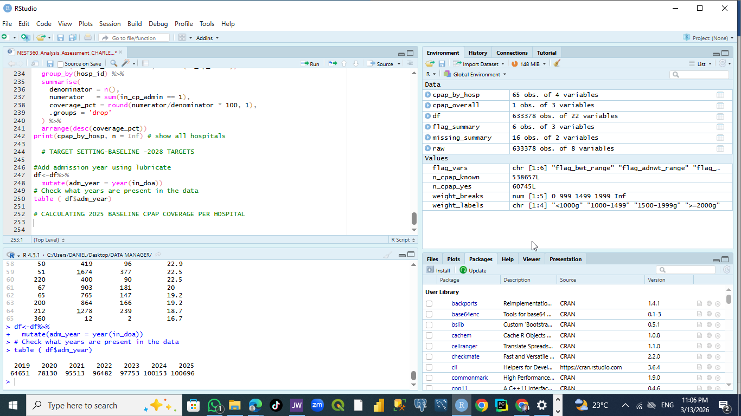
ANNEX:

